G&L Motion Control
PiCPro for Windows Application Note

Document Number: AN000054

Topic: Understanding PiCPro Memory Usage

Scope
This Application Note applies to PiCPro for Windows for all hardware platforms.

Purpose

This Application Note provides information on the different areas of processor memory that PiCPro uses and the commands available for each. It applies generally to all processor types, but specifics may vary based on features available in a particular model.

Introduction

There are several memory areas and types in PiC / MMC products. An understanding of these areas and their uses as well as how their contents can be accessed by PiCPro is needed to effectively use and maintain the units.

The following diagram shows all the memory areas used in the PiC / MMC family of products.
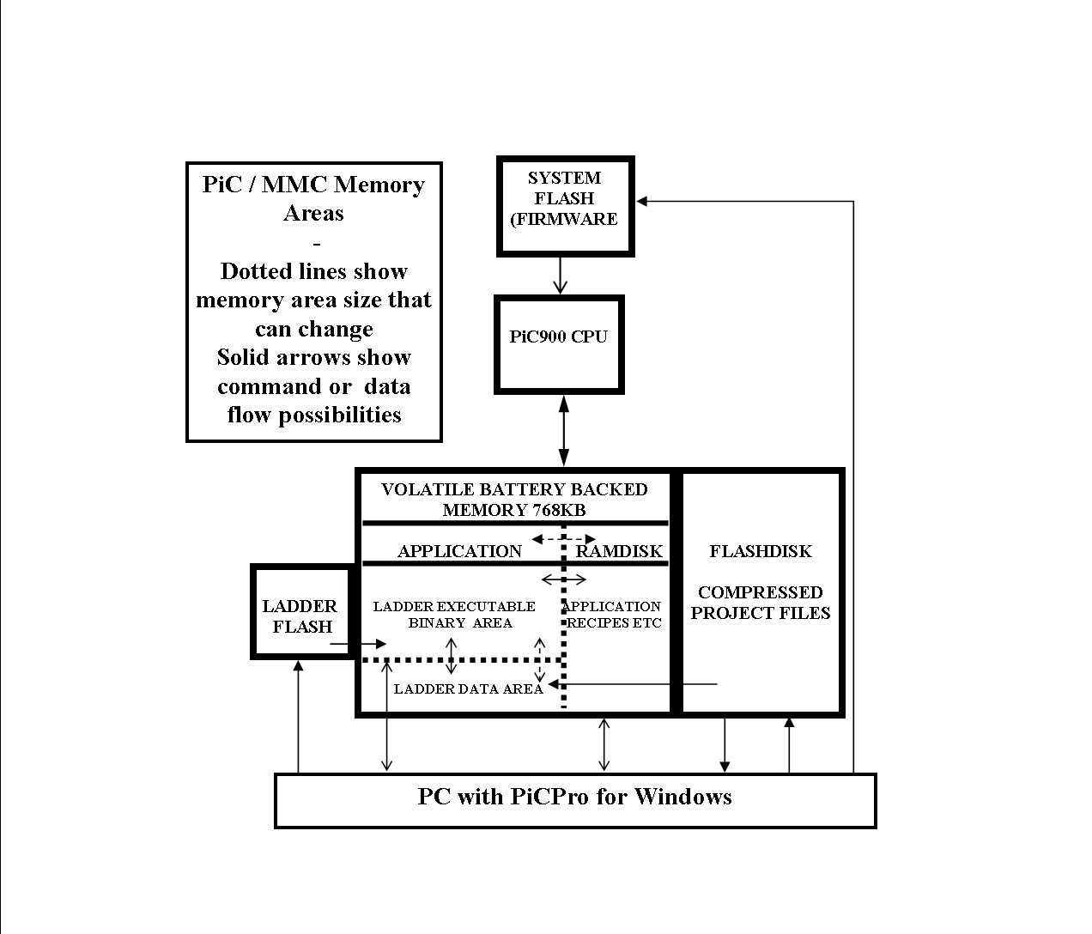

Memory can be either volatile or non volatile. Volatile memory loses its data if power is removed, so backup batteries are typically used to hold up the contents of this type of memory through power outages. CMOS RAM is one type of volatile memory. It is fast, high density and inexpensive.

Non-volatile memory keeps its contents through power outages without battery back up. EPROM was the first type of non volatile memory used. It needed to be programmed in an external EPROM burner before being placed in circuit. If its contents needed changing, it had to be removed from its circuit, erased under ultra violet light and then re programmed. Earlier versions of the PiC90 and PiC900 used EPROM and firmware updates to these processors to accommodate later versions of PiCPro may require purchasing and replacing chips of this type.
A later type of non-volatile memory is EEPROM, also referred to as E²PROM or FLASH. This can be programmed in circuit. The programming is a slower process and can only be done a relatively few times before the chip fails. It is very useful however for system data that only changes infrequently. The MMC uses it for executive firmware. There are also areas of FLASH memory that can be used for ladder executable storage and for project file storage.

PiC900 Memory Organization

There is 768 KB of battery backed memory available. In the standalone MMC, it is configured as 512K of application memory and 256K of ram disk and cannot be changed. In the PiC, MMC_SD and MMC for PC the allocations can be changed by downloading one of the HEX files called CON xxx, where xxx is the amount of application memory assigned, leaving 768 – xxx KB for ram disk. xxx can be 512, 384, 640, 704 or 768. The contents of ram disk and application areas will be lost if you reconfigure, so if necessary, make sure they are backed up before starting.

Application Memory is where the application program is stored. This is battery-backed memory. It is divided in to ladder and data areas by PiCPro during the compile process. PiCPro will automatically assign more data space if software declarations exceed the initial assignment size.

RAMDISK is typically for data storage. It is often used for recipes or setup data for different products that run on the same machine and require different settings. They are stored as files in the same format as DOS / Windows files and can be transferred to a PC using PiCPro. They can also be transferred over an Ethernet connection using TFTP (Trivial File Transfer Protocol). Ladder function blocks such as G_FILMNG are used to transfer file information to and from ladder data memory. The function block M_DATCPT can be used to capture axis data in text format. This can be imported and graphed in Excel for tuning or troubleshooting.

System firmware (FLASH) contains executive code for the system, diagnostics, etc. It may be updated from the PC. There is a file for each processor type and it is written and supported by G & L. Updates for new features and bug fixes are provided for downloading from the G&L website and can be transferred to the MMC using PiCPro. The version of firmware in the processor must match the version of PiCPro being used. Since new purchased products will automatically have the latest firmware included, it will be necessary to install the appropriate version if an earlier version of PiCPro is being used.

FMS (FLASH) Disk is an optional plug in chip on PiC processors but is a standard item with MMC and MMC_SD units. It is mainly used to store all files for complete projects so that they are available to any computer that is connected using PiCPro. However, data transfer is relatively slow and it is always better to have a good backup process in place, especially if multiple PCs are to be used to support a particular PiC900.

Ladder Flash is used to store an image of the ladder diagram executable program. If loaded, the program stored here will be used to replace the ladder diagram BIN image in the CMOS application area each time the processor is power cycled.

These areas will now be explained further, including the PiCPro commands used to access them.

Application Memory
The memory is divided into 2 sections by PiCPro. The Data section is used to store variables that are declared in Software Declarations. The ladder operating program occupies the other section.

PiCPro has a number of ways to access the ladder memory area.

- Full Compile and Download
- Scan Control
- Patch Download
- Binary Backup and Restore
- Clear Application Memory
- PiC Restore

1) The program to run the machine is first written in ladder diagram / structured text format in PiCPro. It is then compiled in to a binary format and when DOWNLOADED is also saved as a file with a .BIN extension on the PC disk drive. The compile process assigns the required amount of data memory and uses the rest for the ladder diagram bin file.

The compiled BIN file cannot be reverse compiled to its original ladder format. So in order to allow online changes and troubleshooting, the same ladder diagram file that the BIN file came from must be used for that purpose. In order to ensure that it is the same file and not a modified one with the same name, a date and time stamp is assigned to the ladder file on disk and to the BIN file and therefore the MMC memory. Before allowing on line monitoring and changes, PiCPro makes sure the date and time stamps match at each end. New stamp values are created at download time if any changes have been detected in the ladder diagram or if it has not been previously downloaded. The first time you download a ladder, you will notice that the Save button comes on even though you had previously saved. This is because the new time stamp values need saved. This mechanism makes it possible to download several processors with the same ladder file and still keep the same date and time stamps.

2) The scan can be stopped from PiCPro. There are several options for starting the scan. They are Cold, Warm, Hot and Single. Hot and Single are for development program troubleshooting and are rarely used. Cold and Warm starts differ as follows. The variables in the Data memory area can be given a retentive R attribute and / or an initial value in Software Declarations. When a full download is done from PiCPro, the ladder diagram must be Soft Started. This means that all variables get their Initial Values before the ladder diagram starts scanning. A power cycle of the processor results in a Warm Restart. In this case, variables with a Retentive attribute keep the value they had prior to the power down point, while all others get their Initial Values again.

From the user point of view, the ladder scan works in typical plc fashion. At the beginning of each scan, the field inputs are read so that their values remain constant for each scan. Block inputs are also read every scan in this manner. The logic is then processed from top to bottom, unless jump or jump subroutine instructions are used. At the end of the logic, all outputs are written to the field devices. The scan then repeats. Since there is only one processor to do ladder and servo operations, the ladder scan is actually interrupted every servo interrupt period to do the work in this area. While this will lengthen the time taken to do the ladder scan, it does not affect the ladder sequence of operations as described. Scan time can be seen on the PiCPro Status bar. If it exceeds 200ms, the scan will stop running and a 1-2-3 error code will flash.

3) In addition to a full compile and download, it is also possible to make changes online to a scanning ladder diagram and do a patch download that changes the running program to include the new logic. The changes are downloaded completely over several scans and then put in effect at the beginning of the next ladder scan. If you do this, you will need to make sure that you save the changes to the PC. Failure to do so will result in a mismatch between the time and date stamps in the MMC and PC and you will no longer be able to animate or make further changes without doing a full download. However, if you don’t download, don’t save even if you are prompted. It is possible while troubleshooting that you created what looks like a ladder change in the PC. Saving a change that wasn’t downloaded will also create a stamp mismatch.

The BIN file is only created when a FULL compile and download is done. Patching the scanning ladder only affects the MMC memory. If you want a current BIN file on the PC disk after patching then you need to do a backup as explained later.

4) The ladder diagram can be backed up from the processor using Online – Control Operations – Backup – Application Program. This should be done after a patch or in situations where current ladder files are not available. Online – Control Operations – Restore will transfer the backed up file to the processor in the event that it needs replaced or the battery failed. The BIN file should only be restored to the same type of processor with the same version of firmware. Otherwise the program may fail to run at all or may fail intermittently and possibly result in unsafe conditions.

5) Clearing the application memory is only used on MMC processors (there is no Run / Stop key switch available as there is on PiC processors). If the ladder diagram program has an infinite loop in it, a scan loss error will occur and it won’t be possible to download a correct program if the scan starts every time power is turned on. The invalid program can be wiped out by doing an Online – Download Hex of the Clear Application Memory Hex file, or an Online – Control Operations – Clear Application Memory command.

6) PiC Restore is a mechanism that allows a data base to be set up of all the files to be used to replace a processor. These include firmware, ladder diagram binary and ram disk. Using this mechanism simplifies the task of processor replacement by saving all the information in one file.

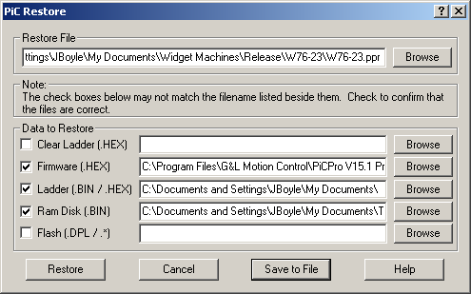

The feature is accessed through Online – Control Operations – PiC Restore. The same window is used to set up and save the file and to open it and restore a processor.

Ladder Data Memory

This memory is set up using Software Declarations. A block of 64 KB is initially allocated by the compiler and this will be raised in 64 KB segments if required to accommodate all the declarations. The amount actually assigned and used will be displayed in the Information Window at each compile operation.

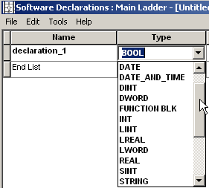
The Name field is the mnemonic given to the element and is used to reference it in the ladder diagram. It can be up to 32 characters. The type field determines the amount of memory used and also how it is used.
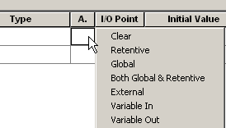
The Attribute field assigns certain characteristics to each element. For example, Retentive will allow the element to keep its value through a power cycle.



The I/O Point column assigns module and point addresses for discrete input and output devices. Analog I/O addresses are referenced on specific function blocks in the ladder diagram. The Initial Value field will be assigned to all elements upon a Cold Restart and to all elements not having a Retentive attribute upon a Warm Restart (power cycle).

The current contents or states of data elements can be seen using Animation or the View List in the ladder diagram. They can also be changed using Forcing in the ladder diagram. Forcing needs to be used very carefully. It will act immediately on the element and may cause a dangerous situation on the equipment if an inappropriate value is chosen.

Forcing is applied at the beginning of a ladder scan to internal bits and variables as well as field inputs. It is applied at the end of the ladder to field outputs. If an internal bit or variable is being written in the ladder diagram, then the forced value will only be in effect from the start of the ladder scan to the network where the write takes place. Also, transitional contacts will not operate correctly using forcing.
Ram Disk

This can be accessed from PiCPro in 2 ways. Online – Control Operations – Disk Operations – Ram Disk gives a Windows Explorer like view and allows basic file management operations such as delete, new folder, copy and paste and so on for both Ram Disk and all the devices on the PC being used to run PiCPro.

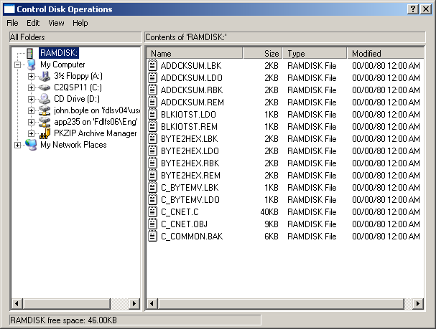
The folder and file names on Ram Disk are restricted to the DOS 8.3 convention.

Ram Disk can be backed up and also have files restored to it using Copy and Paste to / from the PC using this window.

Alternatively, a compressed BIN file can be made using Online – User Program – Backup - Ram Disk. This can then be restored using Online – User Program – Restore and selecting the appropriate BIN file. Some ladder programs are written to require certain files on Ram Disk. If this is the case, then they must be backed up so they can be restored along with the ladder diagram should a battery fail or a CPU need replacing.

System Firmware

This is the equivalent of PC BIOS code. It contains the code to get the CPU started, to run diagnostics, to interface with PiCPro and perform many other common processor operations. It differs for each PiC and MMC model and it will probably change with each PiCPro version and in many cases with service pack releases also. In some instances, updates for critical problems may be found on the Installation / Data Files Errors and Fixes section under Support – Downloads on the G&L Motion Controls web site. Firmware files are in a HEX format and are stored in folders under PiCPro.

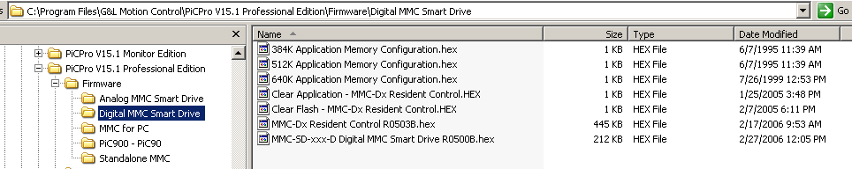
The structure shown was adopted with PiCPro version 15. Earlier versions stored all firmware in one folder and the user had to pick the correct file from the short processor, module or operation related file name.

The version of firmware in the processor must match the version of PiCPro being used.
Since new products will automatically have the latest firmware included, it will be necessary to install the appropriate version if an earlier version of PiCPro is being used.

In addition to CPUs, both analog and digital smart drives have firmware, as do Sercos and TCPIP modules in the PiC family.

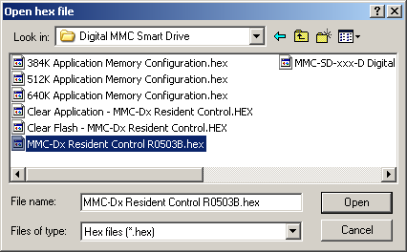
To download firmware, only PiCPro (no ladders or other files) must be open. Select Online – Download Hex and choose the appropriate file. Firmware must be downloaded using a serial cable. Only the MMC-PC allows firmware upgrades over a TCPIP connection.

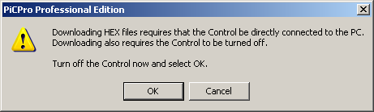

The program that allows firmware to download only starts on a CPU power up condition. So there will be a prompt as shown above. Follow the instructions and turn power off then click OK. The next prompt is to turn power on again, followed by a progress bar showing the firmware downloading. For an MMC_SD with a resident motion card, there will be 2 files to download through the same serial port. Other drives and modules have their own serial ports (it is COM2 for all TCPIP versions). The serial cable must be connected there to update the firmware for that device. For modules such as Sercos, the power needs to be cycled after a download is done.

FMS Disk

The main purpose of this memory is to allow storage of all the files used in the application. This can be particularly important because of the need to have current source ladder files in order to monitor or make changes to a running ladder diagram. Remember it is not possible to upload the currently running program and see it in ladder diagram format.

PiCPro Project Manager has the capability of compressing all the files used into one file with a G&L extension. This can then be saved to Flash Disk and is then available to the next user to open using PiCPro. This gets around the situation where one shift or programmer makes a change on one PC but does not make the changed files readily available to other potential users.

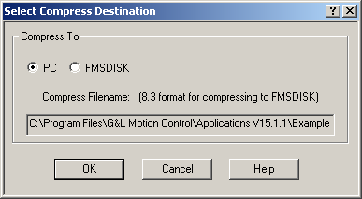
This dialog comes at the end of the Compress Project procedure. Choosing FMSDISK will send the compressed G&L file to the FMS Disk area on the CPU. It is a slow procedure and can take many minutes to complete.
It will also cause the FMSDISK to reformat and wipe out any other files that are stored there.

It is also possible to copy and paste files in the same way that was described earlier for Ram Disk. The ladder diagram can read files from FMSDISK but cannot write to FMSDISK. If the extra security of having setup files read from FMSDISK is wanted, then it will be necessary to compress the G&L file to the PC and copy and paste it to FMSDISK to avoid the reformatting described earlier.

Ladder Flash

All MMC processors have this area as does the PiC9043. PiC900s and the PiC9041 do not have this capability.

This area can be loaded with a copy of the ladder diagram. Every time the processor power is cycled, the contents of this area are transferred to the ladder diagram application program area described earlier. This mainly acts as an insurance against loss of ladder diagram due to battery failure. However, if changes are made to the running ladder and this area is not updated also, then the next time the processor power is cycled, the changes will be lost.

The ladder flash area can be cleared by doing a Download Hex of the Clear Flash file for the processor type. It can be loaded by doing a Compile Hex of the ladder diagram and then a Download Hex of the resulting file. When making changes, be sure to do the clear of the area before downloading the new file.

You must also compile and download the BIN file before doing the Hex compile, otherwise there will not be a valid time stamp.

